**DATA WAREHOUSING AND DATA MINING LAB**

**LAB MANUAL AND RECORD**

**B.TECH**

**(III YEAR – V SEM) (2023-24)**

## DEPARTMENT OF COMPUTER SCIENCE AND ENGINEERING

**Vision**

* To achieve high quality education in technical education that provides the skills and attitude to adapt to the global needs of the Information technology sector, through academic and research excellence.

## Mission

* To equip the students with the cognizance for problem solving and to improve the teaching learning pedagogy by using innovative techniques.
* To strengthen the knowledge base of the faculty and students with the motivation towards possession of effective academic skills and relevant research experience.
* To promote the necessary moral and ethical values among the engineers for the betterment of the society.

## PROGRAMME EDUCATIONAL OBJECTIVES (PEOs)

**PEO1 – PROFESSIONALISM &CITIZENSHIP**

To create and sustain a community of learning in which students acquire knowledge and learn to apply it professionally with due consideration for ethical, ecological and economic issues.

## PEO2 – TECHNICAL ACCOMPLISHMENTS

To provide knowledge based services to satisfy the needs of society and the industry by providing hands on experience in various technologies in core field.

## PEO3 – INVENTION, INNOVATION AND CREATIVITY

To make the students to design, experiment, analyze, interpret in the core field with the help of other multi-disciplinary concepts wherever applicable.

## PEO4 – PROFESSIONAL ETHICS

To educate the students to disseminate research findings with good soft skills and become a successful entrepreneur.

## PEO5 – HUMAN RESOURCE DEVELOPMENT

To graduate the students in building national capabilities in technology, education and research.

## PROGRAM SPECIFIC OUTCOMES (PSOs)

After the completion of the course, B. Tech Information Technology, the graduates will have the following Program Specific Outcomes:

1. **Fundamentals and critical knowledge of the Computer System:-** Able to Understand the working principles of the computer System and its components , Apply the knowledge to build, asses, and analyze the software and hardware aspects of it .
2. **The comprehensive and Applicative knowledge of Software Development:** Comprehensive skills of Programming Languages, Software process models, methodologies, and able to plan, develop, test, analyze, and manage the software and hardware intensive systems in heterogeneous platforms individually or working in teams.
3. **Applications of Computing Domain & Research:** Able to use the professional, managerial, interdisciplinary skill set, and domain specific tools in development processes, identify the research gaps, and provide innovative solutions to them.

## PROGRAM OUTCOMES (POs)

**Engineering Graduates will be able to:**

1. **Engineering knowledge**: Apply the knowledge of mathematics, science, engineering fundamentals, and an engineering specialization to the solution of complex engineering problems.

2. **Problem analysis**: Identify, formulate, review research literature, and analyze complex engineering problems reaching substantiated conclusions using first principles of mathematics, natural sciences, and engineering sciences.

3. **Design / development of solutions**: Design solutions for complex engineering problems and design system components or processes that meet the specified needs with appropriate consideration for the public health and safety, and the cultural, societal, and environmental considerations.

4. **Conduct investigations of complex problems**: Use research-based knowledge and research methods including design of experiments, analysis and interpretation of data, and synthesis of the information to provide valid conclusions.

5. **Modern tool usage**: Create, select, and apply appropriate techniques, resources, and modern engineering and IT tools including prediction and modeling to complex engineering activities with an understanding of the limitations.

6. **The engineer and society**: Apply reasoning informed by the contextual knowledge to assess societal, health, safety, legal and cultural issues and the consequent responsibilities relevant to the professional engineering practice.

7. **Environment and sustainability**: Understand the impact of the professional engineering solutions in societal and environmental contexts, and demonstrate the knowledge of, and need for sustainable development.

8. **Ethics**: Apply ethical principles and commit to professional ethics and responsibilities and norms of the engineering practice.

9. **Individual and team work**: Function effectively as an individual, and as a member or leader in diverse teams, and in multidisciplinary settings.

10. **Communication:** Communicate effectively on complex engineering activities with the engineering community and with society at large, such as, being able to comprehend and write effective reports and design documentation, make effective presentations, and give and receive clear instructions.

11. **Project management and finance** : Demonstrate knowledge and understandingof the engineering and management principles and apply these to one’s own work, as a member and leader in a team, to manage projects and in multi disciplinary environments.

12. **Life- long learning**: Recognize the need for, and have the preparation and abilityto engage in independent and life-long learning in the broadest context of technological change.

|  |  |
| --- | --- |
| 1. | Students are advised to come to the laboratory at least 5 minutes before (to the starting time), those who come after 5 minutes will not be allowed into the lab. |
| 2. | Plan your task properly much before to the commencement, come prepared to the lab  with the synopsis / program / experiment details. |
| 3.  a. | Student should enter into the laboratory with:  Laboratory observation notes with all the details (Problem statement, Aim, |
|  | Algorithm, Procedure, Program, Expected Output, etc.,) filled in for the lab session. |
| b. | Laboratory Record updated up to the last session experiments and other utensils (if |
|  | any) needed in the lab. |
| c.  4. | Proper Dress code and Identity card.  Sign in the laboratory login register, write the TIME-IN, and occupy the computer |
|  | system allotted to you by the faculty. |
| 5. | Execute your task in the laboratory, and record the results / output in the lab |
|  | observation note book, and get certified by the concerned faculty. |
| 6. | All the students should be polite and cooperative with the laboratory staff, must |
|  | maintain the discipline and decency in the laboratory. |
| 7. | Computer labs are established with sophisticated and high end branded systems,  which should be utilized properly. |
| 8. | Students / Faculty must keep their mobile phones in SWITCHED OFF mode during |
|  | the lab sessions. Misuse of the equipment, misbehaviors with the staff and systems |
|  | etc., will attract severe punishment. |
| 9. | Students must take the permission of the faculty in case of any urgency to go out ; if |
|  | anybody found loitering outside the lab / class without permission during working |
|  | hours will be treated seriously and punished appropriately. |

10. Students should LOG OFF/ SHUT DOWN the computer system before he/she leaves the lab after completing the task (experiment) in all aspects. He/she must ensure the system / seat is kept properly.

**Head of the Department Principal**

# COURSE NAME: DATA WAREHOUSING AND DATA MINING LAB COURSE CODE:

**COURSE OBJECTIVES:**

1. Learn how to build a data warehouse and query it (using open source tools like Pentaho Data Integration Tool, Pentaho Business Analytics).
2. Learn to perform data mining tasks using a data mining toolkit (such as opensource WEKA).
3. Understand the data sets and data preprocessing.
4. Demonstrate the working of algorithms for data mining tasks such association rule mining,classification, clustering and regression.
5. Exercise the data mining techniques with varied input values for different parameters.
6. To obtain Practical Experience Working with all real datasets.

# COURSE OUTCOMES:

1. Ability to add mining algorithms as a component to the existing tools
2. Demonstrate the classification, clustering and etc. in large data sets.
3. Ability to apply mining techniques for realistic data.

## MAPPING OF COURSE OUTCOMES WITH PROGRAM OUTCOMES:

|  |  |  |  |  |  |  |  |  |  |  |  |
| --- | --- | --- | --- | --- | --- | --- | --- | --- | --- | --- | --- |
| **COURSE OUTCOMES** | **PO1** | **PO2** | **PO3** | **PO4** | **PO5** | **PO6** | **PO7** | **PO8** | **P09** | **PO10** | **PO11** |
| * Ability to add mining algorithms as acomponent to theexiting tools. * Ability to apply mining techniques for realistic data. | √ | √ | √ |  |  |  |  |  |  |  | √ |

DATAWARE HOUSE TOOLS

|  |  |
| --- | --- |
| Cloudera |  |
| Teradata |  |
| Oracle |  |
| TabLeau |  |

OPEN SOURCE DATA MINING TOOLS

|  |  |
| --- | --- |
| WEKA |  |
| Orange |  |
| KNIME |  |
| R-Programming |  |

# DATA WAREHOUSING AND DATA MINING LAB INDEX

|  |  |  |  |  |
| --- | --- | --- | --- | --- |
| **S.No** | **Name of the Experiment** | **Pg No** | **Date** | **Signature** |
| 1 | Installation of WEKA Tool | 1 |  |  |
| 2 | Creating new Arff File | 11 |  |  |
| 3 | Data Processing Techniques on Data set | 16 |  |  |
| 4 | Data cube construction – OLAP operations | 25 |  |  |
| 5 | Implementation of Apriori algorithm | 33 |  |  |
| 6 | Implementation of FP- Growth algorithm | 45 |  |  |
| 7 | Implementation of Decision Tree Induction | 54 |  |  |
| 8 | Calculating Information gains measures | 63 |  |  |
| 9 | Classification of data using Bayesian approach | 68 |  |  |
| 10 | Implementation of K-means algorithm | 76 |  |  |
| 11 | **Case Study:** Create Placement.arff file to identify the students who are eligible for placements using KNN | 85 |  |  |

**Experiment 1: Installation of WEKA Tool**

**Aim: A. Investigation the Application interfaces of the Weka tool. Introduction:**

# Introduction

Weka (pronounced to rhyme with Mecca) is a workbench that contains a collection of visualization tools and algorithms for data analysis and predictive modeling, together with graphical user interfaces for easy access to these functions. The original non-Java version of Weka was a Tcl/Tk front-end to (mostly third-party) modeling algorithms implemented in other programming languages, plus data preprocessing utilities in C, and Make file-based system for running machine learning experiments. This original version was primarily designed as a tool for analyzing data from agricultural domains, but the more recent fully Java-based version (Weka 3), for which development started in 1997, is now used in many different application areas, in particular for educational purposes and research. Advantages of Weka include:

* Free availability under the GNU General Public License.
* Portability, since it is fully implemented in the Java programming language and thus runs on almost any modern computing platform
* A comprehensive collection of data preprocessing and modeling techniques
* Ease of use due to its graphical user interfaces

## Description:

Open the program. Once the program has been loaded on the user’s machine it is opened by navigating to the programs start option and that will depend on the users operating system. Figure

1.1 is an example of the initial opening screen on a computer. There are four options available on this initial screen:

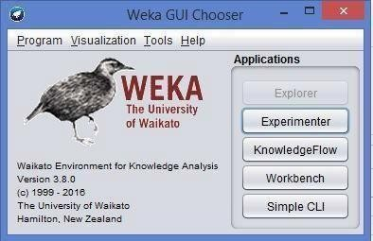

Fig: 1.1 Weka GUI

**1. Explorer** - the graphical interface used to conduct experimentation on raw data After clicking the Explorer button the weka explorer interface appears.

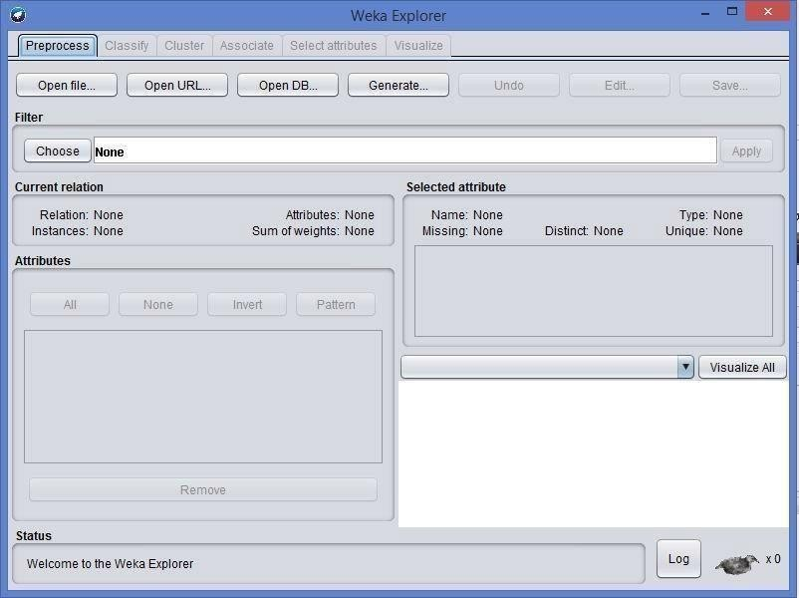

Fig: 1.2 Pre-processor

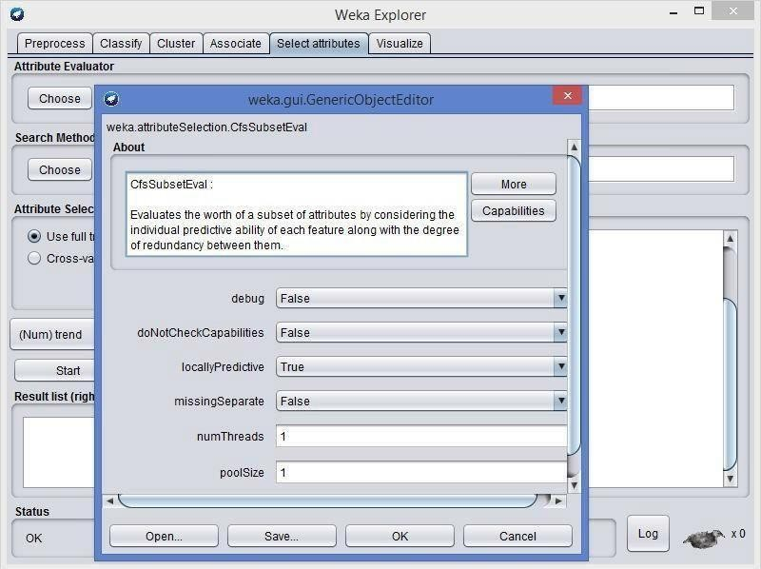

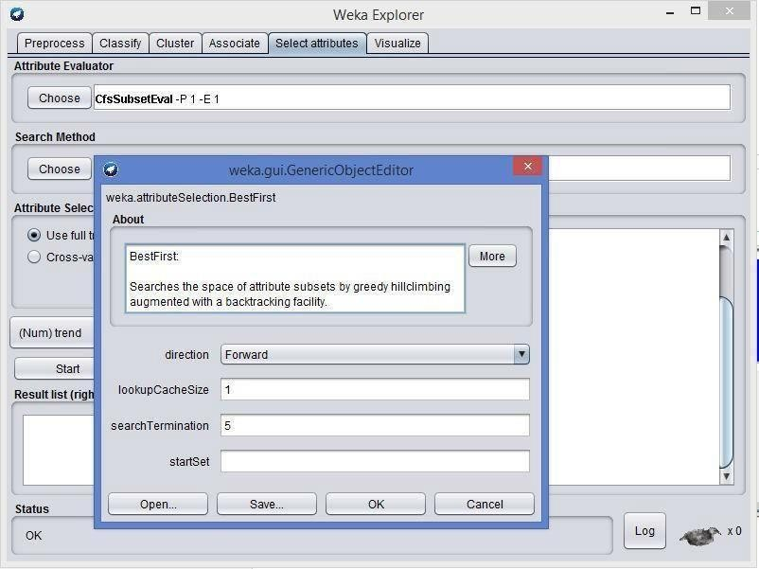

Inside the weka explorer window there are six tabs:

1. **Preprocess-** used to choose the data file to be used by the application.

**Open File**- allows for the user to select files residing on the local machine or recorded medium **Open URL**- provides a mechanism to locate a file or data source from a different location specified by the user

**Open Database**- allows the user to retrieve files or data from a database source provided by user

1. **Classify-** used to test and train different learning schemes on the preprocessed data file under experimentation

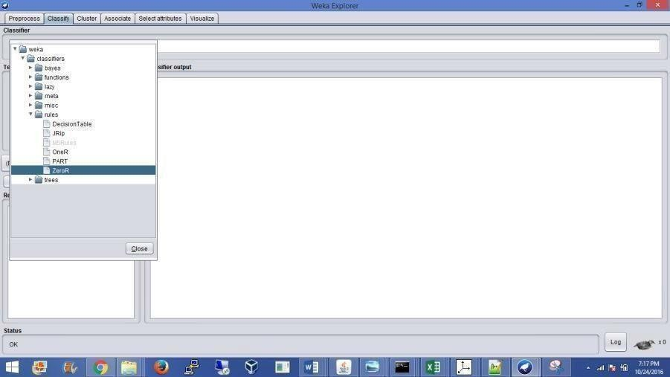

Fig: 1.3 choosing Zero set from classify

Again there are several options to be selected inside of the classify tab. Test option gives the user the choice of using four different test mode scenarios on the data set.

* 1. Use training set
  2. Supplied training set
  3. Cross validation
  4. Split percentage

1. **Cluster-** used to apply different tools that identify clusters within the data file.

The Cluster tab opens the process that is used to identify commonalties or clusters of occurrences within the data set and produce information for the user to analyze.

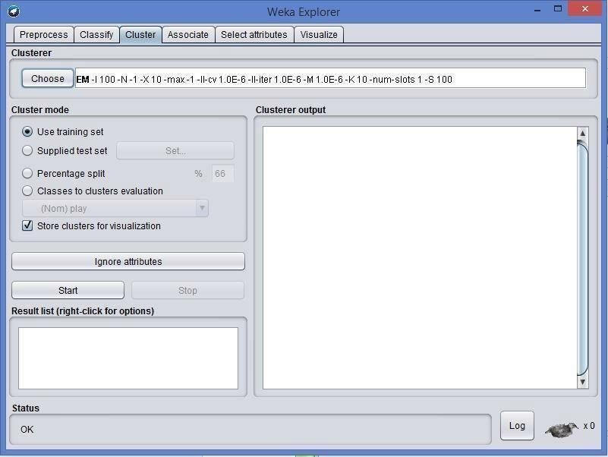

1. **Association-** used to apply different rules to the data file that identify association within the data. The associate tab opens a window to select the options for associations within thedataset.

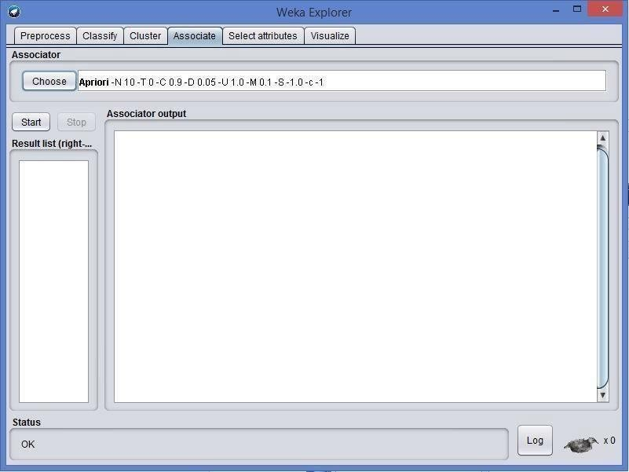

1. **Select attributes-**used to apply different rules to reveal changes based on selected attributes inclusion or exclusion from the experiment
2. **Visualize-** used to see what the various manipulation produced on the data set in a 2D format, in scatter plot and bar graph output.
3. **Experimenter** - this option allows users to conduct different experimental variations on data sets and perform statistical manipulation. The Weka Experiment Environment enables the user to create, run, modify, and analyze experiments in a more convenient manner than is possible when processing the schemes individually. For example, the user can create an experiment that runs several schemes against a series of datasets and then analyze the results to determine if one of the schemes is (statistically) better than the other schemes.

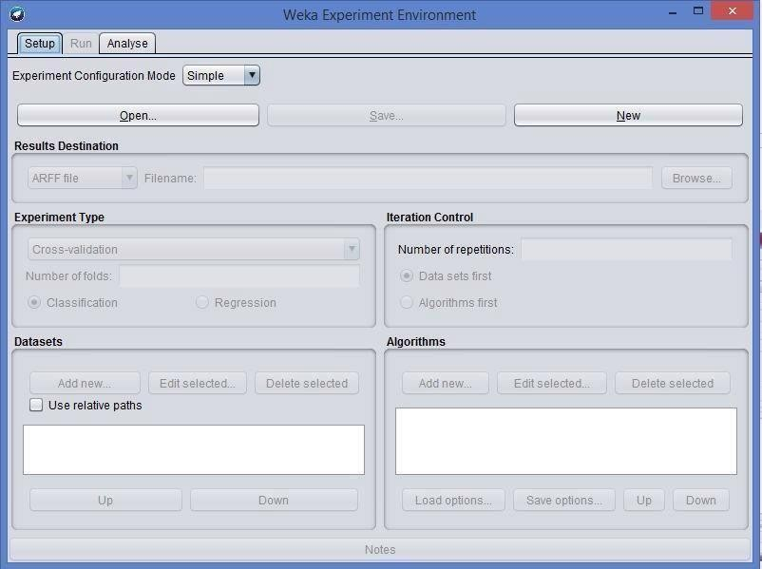

Fig: 1.6 Weka experiment

**Results destination**: ARFF file, CSV file, JDBC database.

**Experiment type**: Cross-validation (default), Train/Test Percentage Split (data randomized).

**Iteration control**: Number of repetitions, Data sets first/Algorithms first.

**Algorithms**: filters

1. **Knowledge Flow** -basically the same functionality as Explorer with drag and drop functionality. The advantage of this option is that it supports incremental learning from previous results
2. **Simple CLI** - provides users without a graphic interface option the ability to execute commands from a terminal window.

## b. Explore the default datasets in weka tool.

Click the “***Open file…***” button to open a data set and double click on the “***data***” directory. Weka provides a number of small common machine learning datasets that you can use to practice on. Select the “***iris.arff***” file to load the Iris dataset.

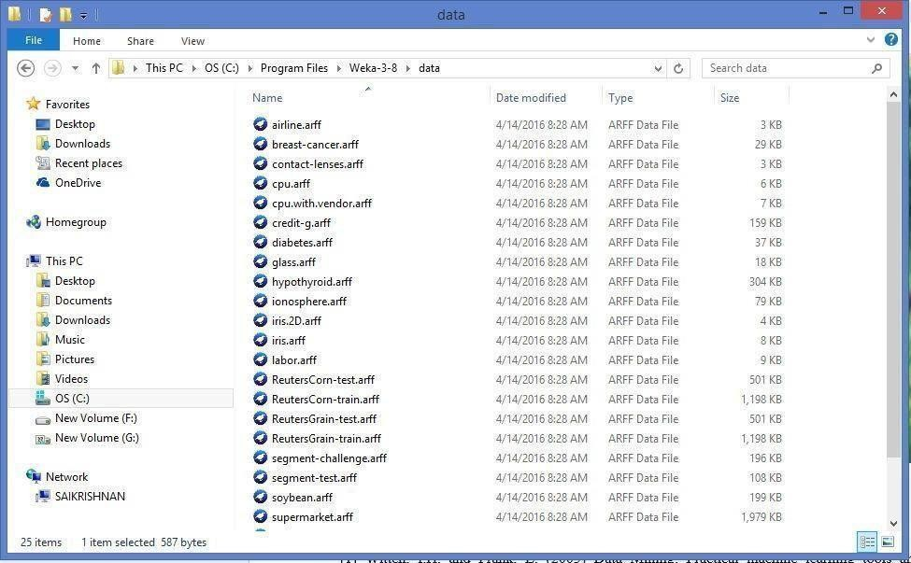

Fig: 1.7 Different Data Sets in weka

## References:

1. Witten, I.H. and Frank, E. (2005) Data Mining: Practical machine learning tools andtechniques. 2nd edition Morgan Kaufmann, San Francisco.
2. Ross Quinlan (1993). C4.5: Programs for Machine Learning, Morgan Kaufmann Publishers, San Mateo, CA.
3. CVS[–http://weka.sourceforge.net/wiki/index.php/CVS](http://weka.sourceforge.net/wiki/index.php/CVS)
4. Weka Doc–<http://weka.sourceforge.net/wekadoc/>

Exercise:

* 1. Normalize the data using min-max normalization

# Record Notes

**Experiment 2: Creating new ARFF file**

## Aim: Creating a new ARFF file

An ARFF (Attribute-Relation File Format) file is an ASCII text file that describes a list of instances sharing a set of attributes. ARFF files were developed by the Machine Learning Project at the Department of Computer Science of The University of Waikato for use with the Weka machine learning software in WEKA, each data entry is an instance of the java class weka.core. Instance, and each instance consists of a For loading datasets in WEKA, WEKA can load ARFF files. Attribute Relation File Format has two sections:

* + 1. The Header section defines relation (dataset) name, attribute name, and type.
    2. The Data section lists the data instances.

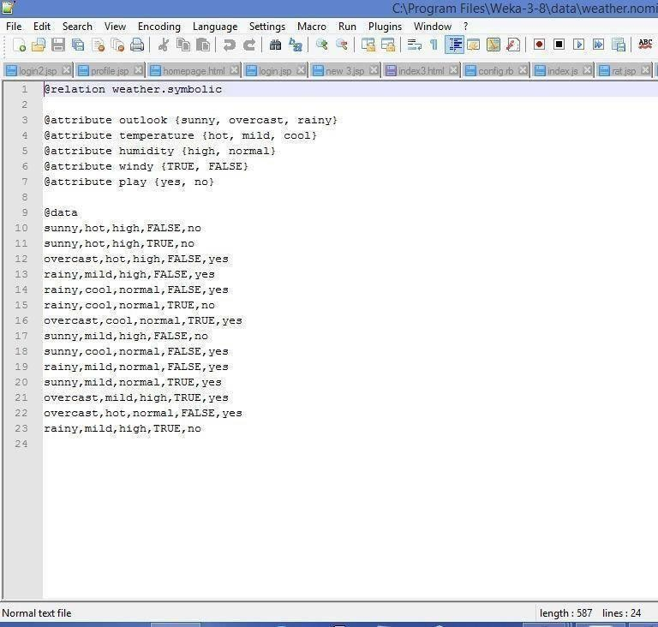

The figure above is from the textbook that shows an ARFF file for the weather data. Lines beginning with a % sign are comments. And there are three basic keywords:





The external representation of an Instances class Consists of:

* **A header:** Describes the attribute types
* **Data section:** Comma separated list of data

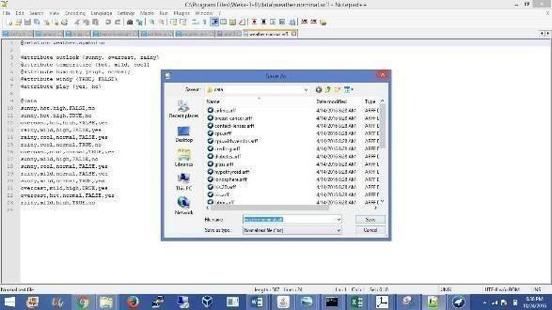

## References:

https:/[/www.cs.auckland.](http://www.cs.auckland.ac.nz/courses/compsci367s1c/tutorials/IntroductionToWeka.pdf)a[c.nz/courses/compsci367s1c/tutorials/IntroductionToWeka.pdf](http://www.cs.auckland.ac.nz/courses/compsci367s1c/tutorials/IntroductionToWeka.pdf)

Exercise:

1. Creating a sample dataset for supermarket (supermarket.arff)

# Record Notes

**Experiment 3: Data Processing Techniques on Data Set**

## Aim: 3a) Pre-process a given dataset based on Attribute selection

To search through all possible combinations of attributes in the data and find which subset of attributes works best for prediction, make sure that you set up attribute evaluator to „Cfs Subset Val‟ and a search method to „Best First‟. The evaluator will determine what method to use toassign a worth to each subset of attributes. The search method will determine what style of search to perform. The options that you can set for selection in the „Attribute Selection Mode‟ fig no: 3.2

1. **Use full training set.** The worth of the attribute subset is determined using the full set of training data.
2. **Cross-validation.** The worth of the attribute subset is determined by a process of cross- validation. The „Fold‟ and „Seed‟ fields set the number of folds to use and the random seed used when shuffling the data.

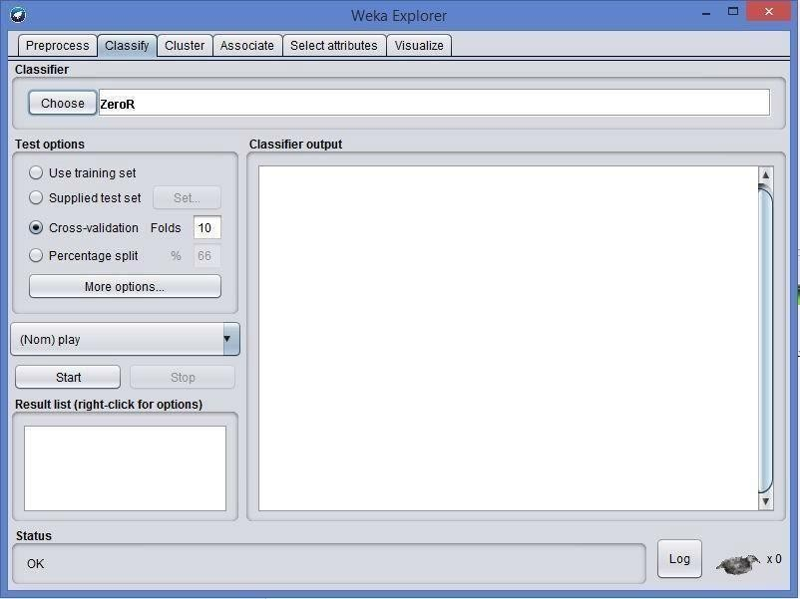Specify which attribute to treat as the class in the drop-down box below the test options. Once all the test options are set, you can start the attribute selection process by clicking on „Start‟ button.

Fig: 3.1 Choosing Cross validation

When it is finished, the results of selection are shown on the right part of the window and entry is added to the „Result list‟.

# 2. Visualizing Results

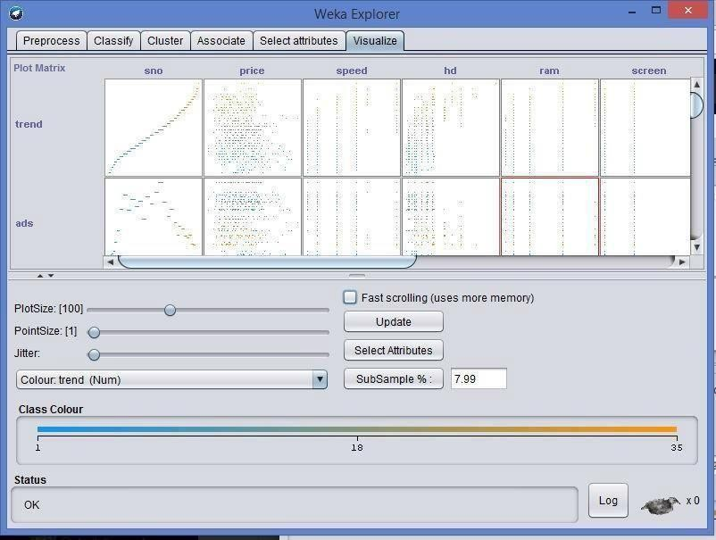

Fig: 3.2 Data Visualization

WEKA‟s visualization allows you to visualize a 2-D plot of the current working relation. Visualization is very useful in practice; it helps to determine difficulty of the learning problem. WEKA can visualize single attributes (1-d) and pairs of attributes (2-d), rotate 3-d visualizations (Xgobi-style). WEKA has “Jitter” option to deal with nominal attributes and to detect “hidden” data points.

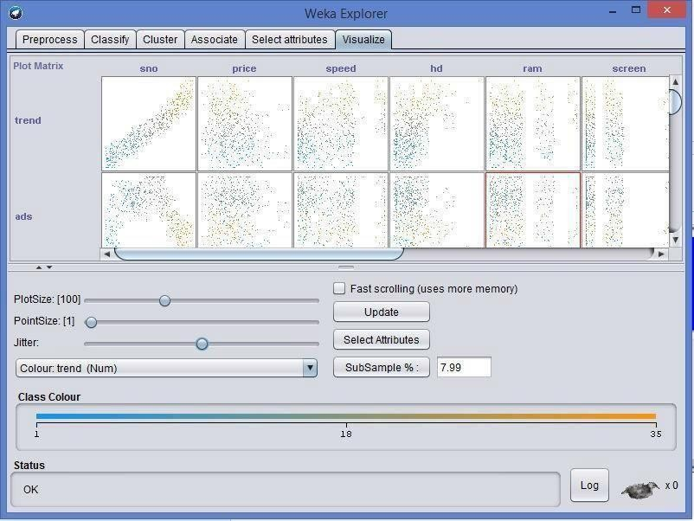

Fig 3.3: Preprocessing with jitter

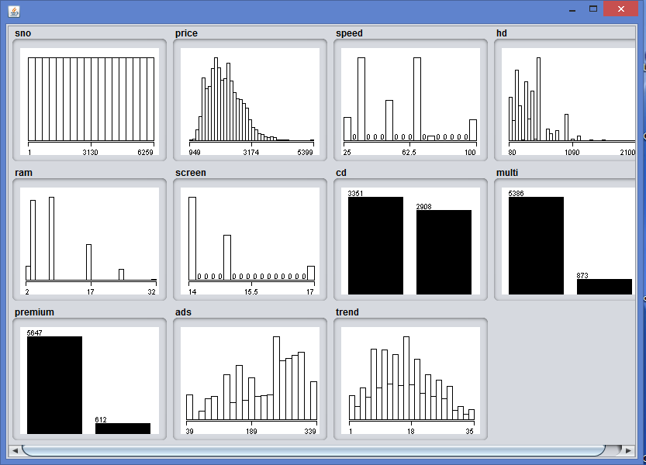

Exercise

Fig: 3.3 Data visualization

1. Explain data preprocessing steps for heart disease dataset.

# Aim: B. Pre-process a given dataset based on Handling Missing Values

**Process**: Replacing Missing Attribute Values by the Attribute Mean. This method is used for data sets with numerical attributes. An example of such a data set is presented in fig no: 3.4

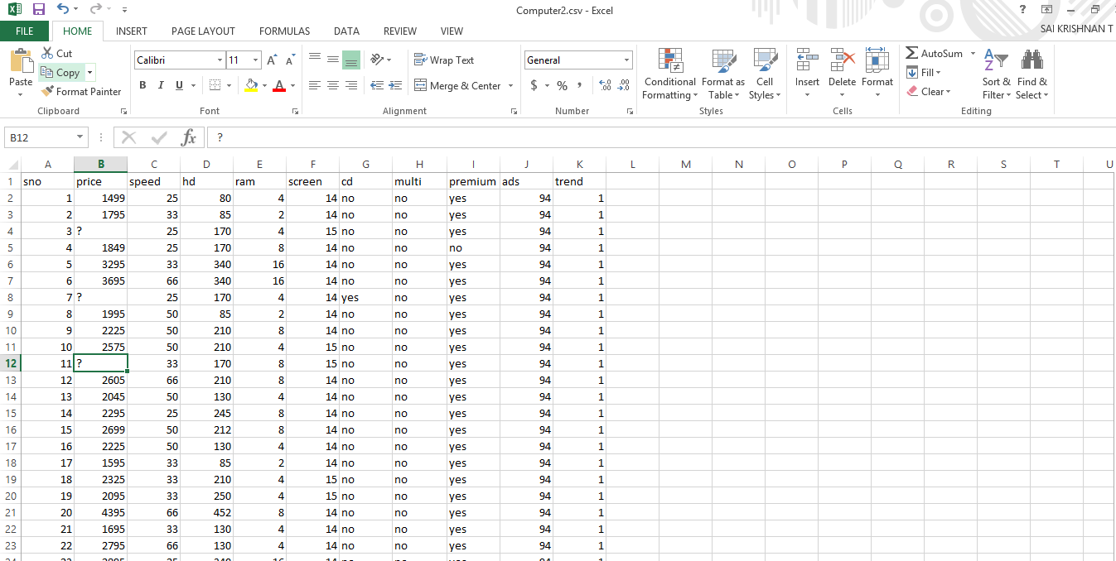

Fig: 3.4 Missing values

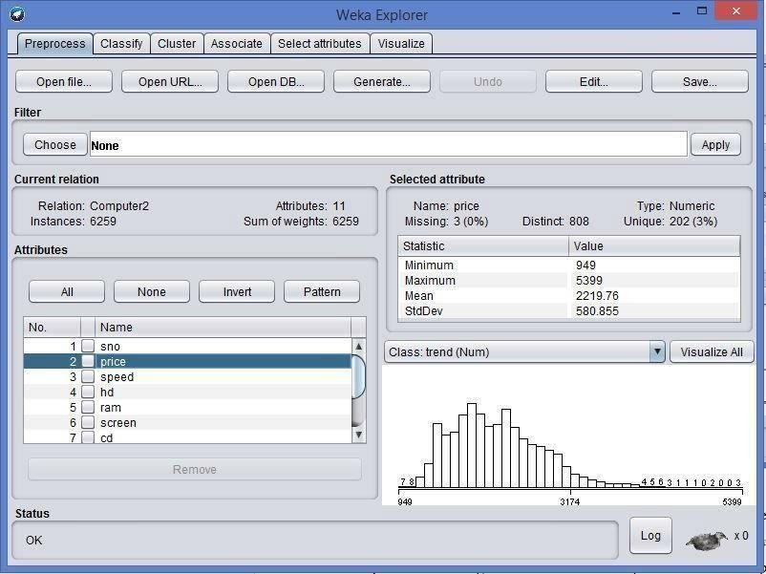

Fig: 3.5 Choosing a dataset

In this method, every missing attribute value for a numerical attribute is replaced by the arithmetic mean of known attribute values. In Fig, the mean of known attribute values for Temperature is 99.2, hence all missing attribute values for Temperature should be replaced by The table with missing attribute values replaced by the mean is presented in fig. For symbolic attributes Headache and Nausea, missing attribute values were replaced using the most common value of the Replace Missing Values.

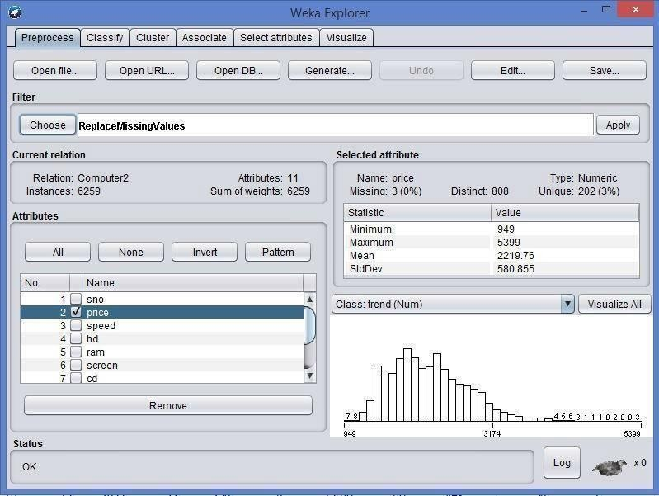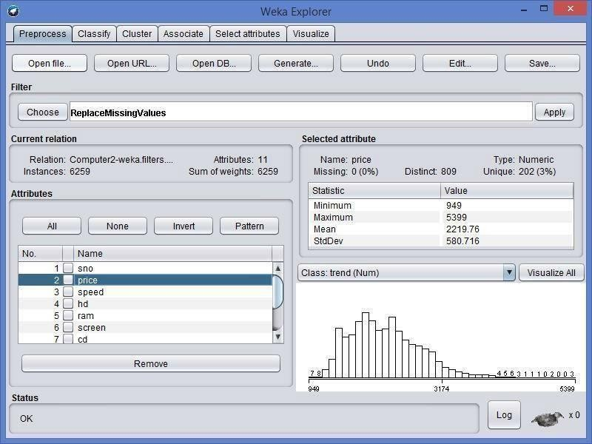

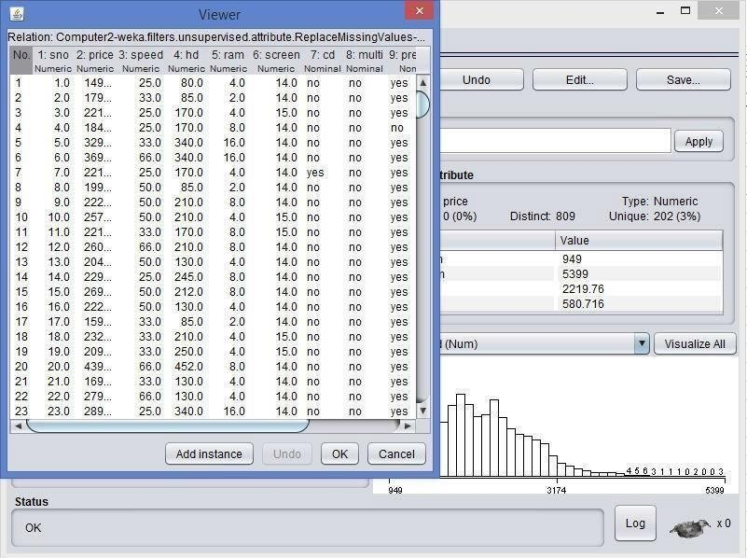

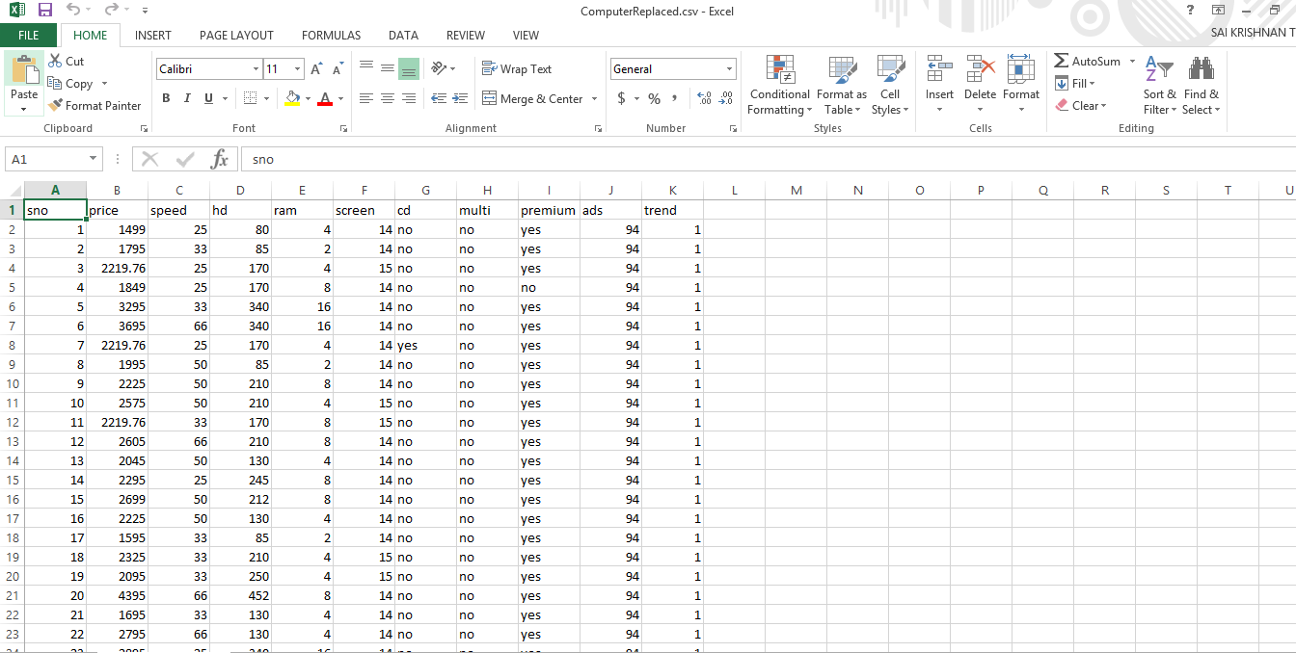

Fig: 3.6 Replaced values

Exercise

* 1. Create your own dataset having missing values included.

# Record Notes

**Experiment 4: Data cube construction – OLAP operations**

An OLAP cube is a term that typically refers to multi-dimensional array of data. OLAP is an acronym for online analytical processing,[1]which is a computer-based technique of analyzing data to look for insights. The term cube here refers to a multi-dimensional dataset, which is also sometimes called a hypercube if the number of dimensions is greater than 3.

## Operations:

1. **Slice** is the act of picking a rectangular subset of a cube by choosing a single value for one of its dimensions, creating a new cube with one fewer dimension.[4] The picture shows a slicing operation: The sales figures of all sales regions and all product categories of the company in the year 2005 and 2006 are "sliced" out of the data cube.
2. **Dice:** The dice operation produces a subcube by allowing the analyst to pick specific values of multiple dimensions.[5]The picture shows a dicing operation: The new cube shows the sales figures of a limited number of product categories, the time and region dimensions cover the same range as before.
3. **Drill Down/Up** allows the user to navigate among levels of data ranging from the most summarized (up) to the most detailed (down).[4] The picture shows a drill-down operation: The analyst moves from the summary category "Outdoor-Schutzausrüstung" to see the sales figures for the individual products.
4. **Roll-up:** A roll-up involves summarizing the data along a dimension. The summarization rule might be computing totals along a hierarchy or applying a set of formulas such as "profit = sales

- expenses".

1. **Pivot** allows an analyst to rotate the cube in space to see its various faces. For example, cities could be arranged vertically and products horizontally while viewing data for a particular quarter. Pivoting could replace products with time periods to see data across time for a single product.

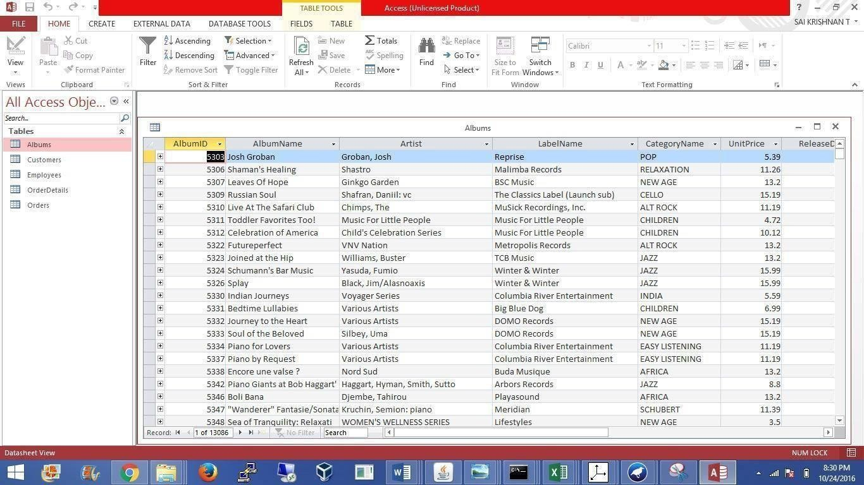

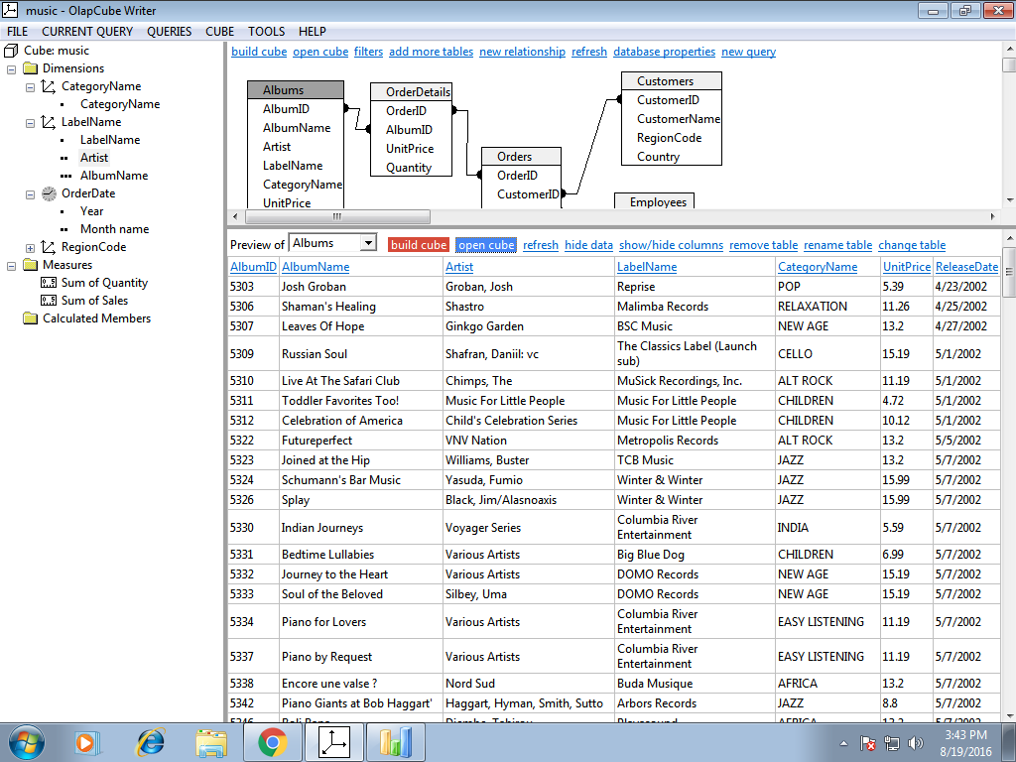

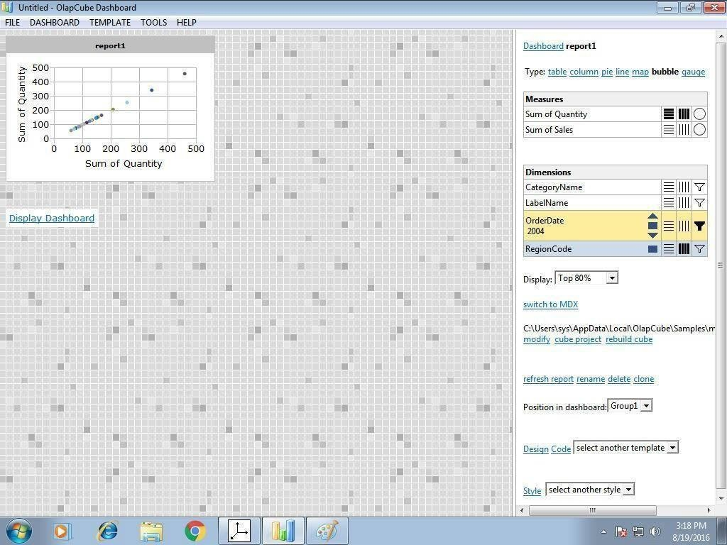

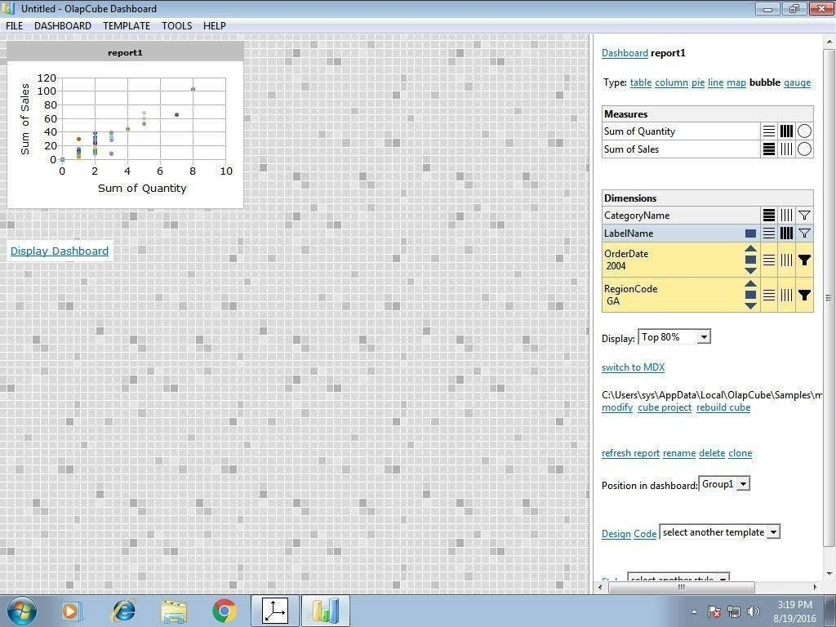

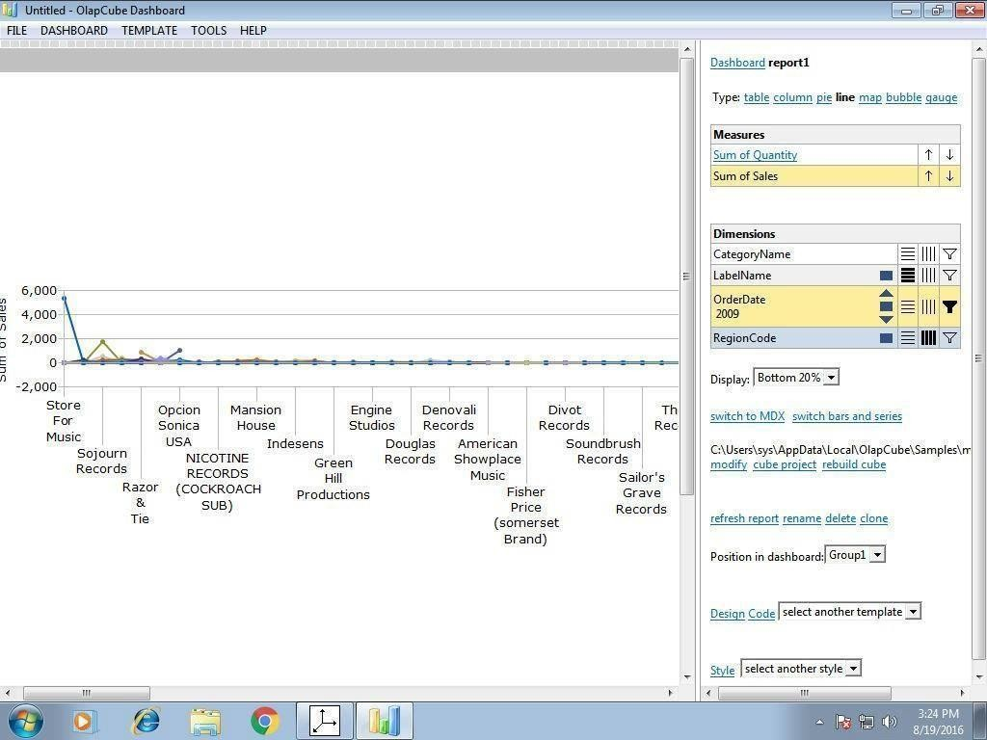

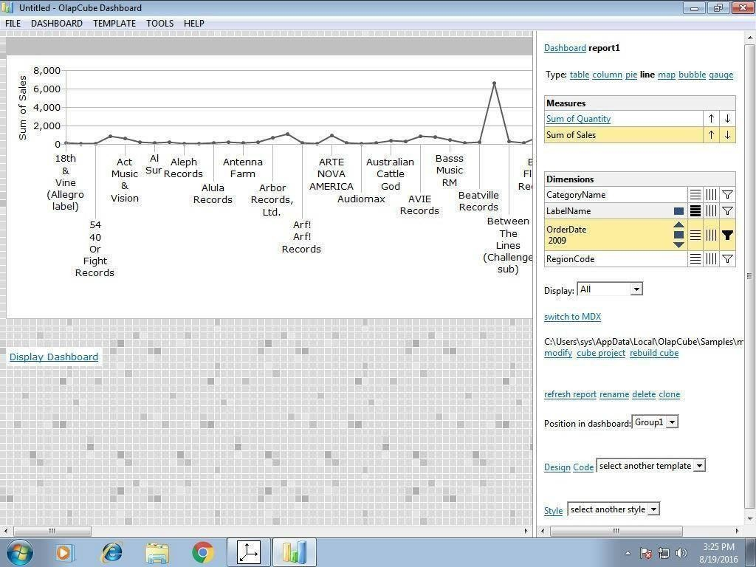

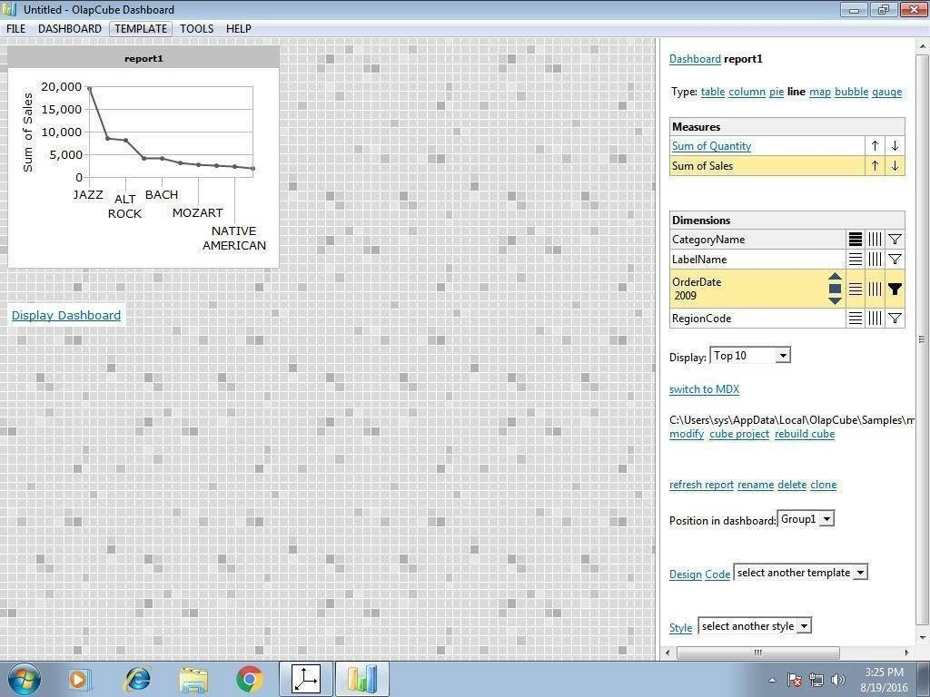

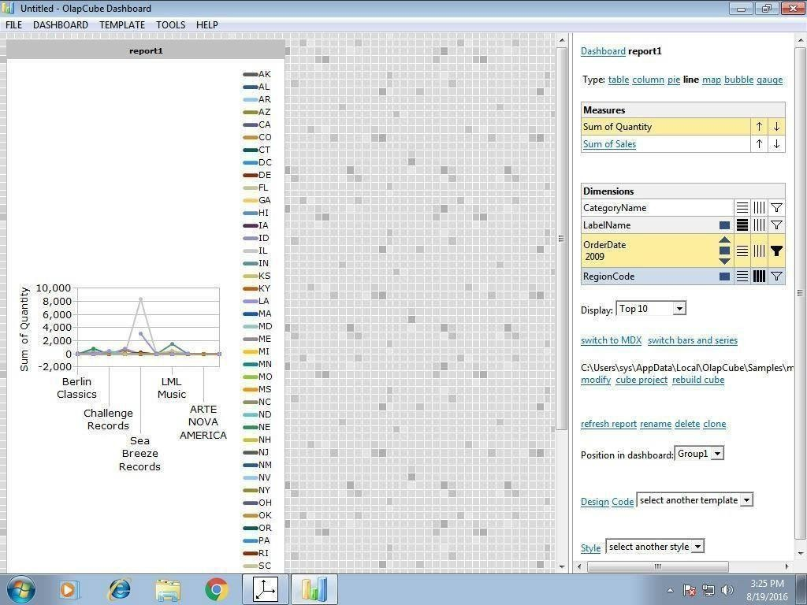

Exercise:

* 1. Apply the OLAP operations for the above banking application.

# Record Notes

**Experiment 5: Implementation of Apriori Algorithm**

## Description:

The Apriori algorithm is an influential algorithm for mining frequent item sets for Boolean association rules. It uses a “bottom-up” approach, where frequent subsets are extended one at a time (a step known as candidate generation, and groups of candidates are tested against the data).

## Problem:

|  |  |
| --- | --- |
| **TID** | **ITEMS** |
| 100 | 1,3,4 |
| 200 | 2,3,5 |
| 300 | 1,2,3,5 |
| 400 | 2,5 |

To find frequent item sets for above transaction with a minimum support of 2 having confidence measure of 70% (i.e, 0.7).

## Procedure:

Step 1:

Count the number of transactions in which each item occurs

|  |  |
| --- | --- |
| **TID** | **ITEMS** |
| 1 | 2 |
| 2 | 3 |
| 3 | 3 |
| 4 | 1 |
| 5 | 3 |

Step 2:

Eliminate all those occurrences that have transaction numbers less than the minimum support ( 2 in this case).

|  |  |
| --- | --- |
| **ITEM** | **NO. OF TRANSACTIONS** |
| 1 | 2 |
| 2 | 3 |
| 3 | 3 |
| 5 | 3 |

This is the single items that are bought frequently. Now let’s say we want to find a pair of items that are bought frequently. We continue from the above table (Table in step 2).

Step 3:

We start making pairs from the first item like 1,2;1,3;1,5 and then from second item like 2,3;2,5. We do not perform 2,1 because we already did 1,2 when we were making pairs with 1 and buying 1 and 2 together is same as buying 2 and 1 together. After making all the pairs we get,

|  |
| --- |
| **ITEM PAIRS** |
| 1,2 |
| 1,3 |
| 1,5 |
| 2,3 |
| 2,5 |
| 3,5 |

Step 4:

Now, we count how many times each pair is bought together.

|  |  |
| --- | --- |
| **ITEM PAIRS** | **NO.OF TRANSACTIONS** |
| 1,2 | 1 |
| 1,3 | 2 |
| 1,5 | 1 |
| 2,3 | 2 |
| 2,5 | 3 |
| 3,5 | 2 |

Step 5:

Again remove all item pairs having number of transactions less than 2.

|  |  |
| --- | --- |
| **ITEM PAIRS** | **NO. OF TRANSACTIONS** |
| 1,3 | 2 |
| 2,3 | 2 |
| 2,5 | 3 |
| 3,5 | 2 |

These pair of items is bought frequently together. Now, let’s say we want to find a set of three items that are bought together. We use above table (of step 5) and make a set of three items.

Step 6:

To make the set of three items we need one more rule (It is termed as self-join), it simply means, from item pairs in above table, we find two pairs with the same first numeric, so, we get (2,3) and (2,5), which gives (2,3,5). Then we find how many times (2, 3, 5) are bought together in the original table and we get the following

|  |  |
| --- | --- |
| **ITEM SET** | **NO. OF TRANSACTIONS** |
| (2,3,5) | 2 |

Thus, the set of three items that are bought together from this data are (2, 3, 5). Confidence:

We can take our frequent item set knowledge even further, by finding association rules using the frequent item set. In simple words, we know (2, 3, 5) are bought together frequently, but what is the association between them. To do this, we create a list of all subsets of frequently bought items (2, 3, 5) in our case we get following subsets:

* {2}
* {3}
* {5}
* {2,3}
* {3,5}
* {2,5}

Now, we find association among all the subsets.

{2} => {3,5}:( If„2‟ is bought , what‟s the probability that „3‟ and „5‟ would be bought in same transaction)

Confidence = P (3฀5฀2)/ P(2) =2/3 =67%

{3}=>{2,5}= P (3฀5฀2)/P(3)=2/3=67%

{5}=>{2,3}= P (3฀5฀2)/P(5)=2/3=67%

{2,3}=>{5}= P (3฀5฀2)/P(2฀3)=2/2=100%

{3,5}=>{2}= P (3฀5฀2)/P(3฀5)=2/2=100%

{2,5}=>{3}= P (3฀5฀2)/ P(2฀5)=2/3=67%

Also, considering the remaining 2-items sets, we would get the following associations-

{1}=>{3}=P(1฀3)/P(1)=2/2=100%

{3}=>{1}=P(1฀3)/P(3)=2/3=67%

{2}=>{3}=P(3฀2)/P(2)=2/3=67%

{3}=>{2}=P(3฀2)/P(3)=2/3=67%

{2}=>{5}=P(2฀5)/P(2)=3/3=100%

{5}=>{2}=P(2฀5)/P(5)=3/3=100%

{3}=>{5}=P(3฀5)/P(3)=2/3=67%

{5}=>{3}=P(3฀5)/P(5)=2?3=67%

Eliminate all those having confidence less than 70%. Hence, the rules would be –

{2,3}=>{5}, {3,5}=>{2}, {1}=>{3},{2}=>{5}, {5}=>{2}.

* Now these manual results should be checked with the rules generated in WEKA.

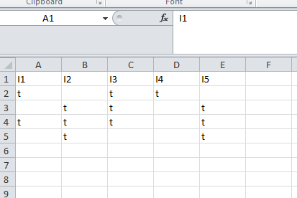

So first create a csv file for the above problem, the csv file for the above problem will look like the rows and columns in the above figure. This file is written in excel sheet.

## Procedure for running the rules in weka:

**Step 1:**

Open weka explorer and open the file and then select all the item sets. The figure gives a better understanding of how to do that.

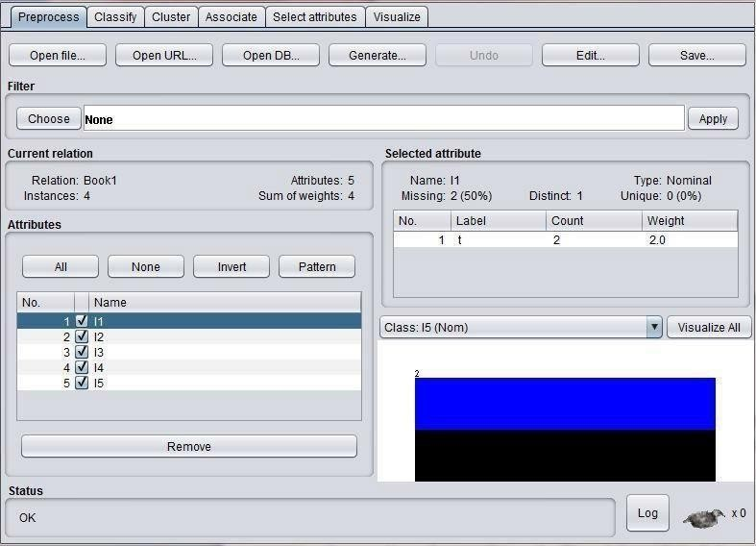

## Step 2:

Now select the association tab and then choose apriori algorithm by setting the minimumsupport and confidence as shown in the figure

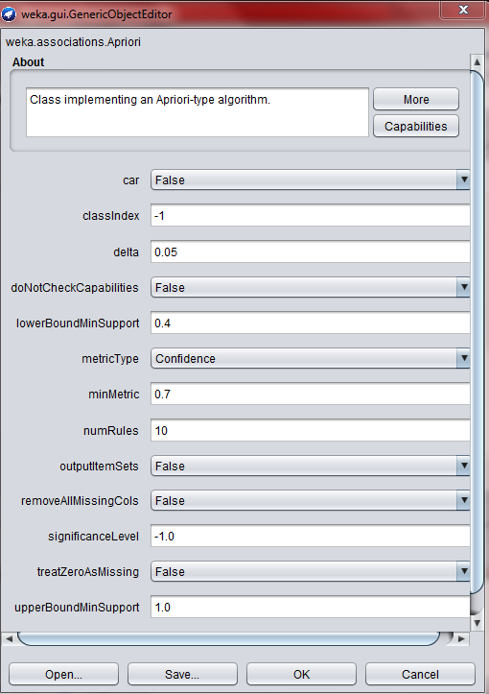

## Step 3:

Now run the apriori algorithm with the set values of minimum support and the confidence. After running the weka generates the association rules and the respective confidence with minimum support as shown in the figure.

The above csv file has generated 5 rules as shown in the figure:

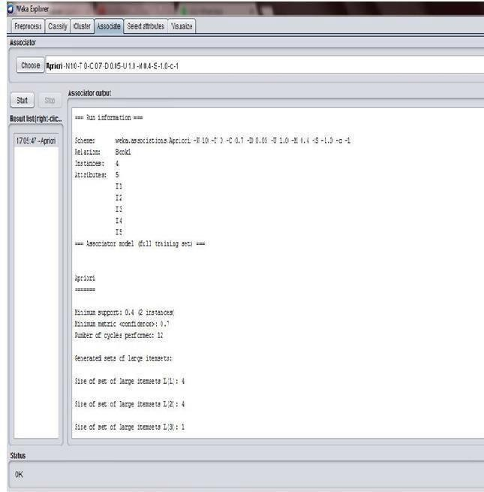

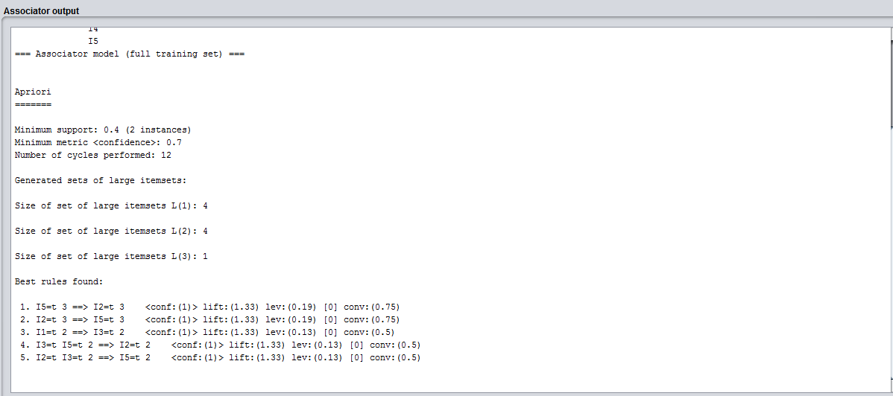

## Conclusion:

As we have seen the total rules generated by us manually and by the weka are matching, hence the rules generated are 5.

Exercise:

1.Apply the Apriori algorithm on Airport noise monitoring dataset discriminating between patients with parkin sons and neurological diseases using voice recording dataset. [https://archive.ics.uci.edu/ml/machine-learning-databases/00000/ refer this link for datasets]

# Record Notes

**Experiment 6: Implementation of FP- Growth Algorithm**

**(5a) Aim**: To generate association rules using FP Growth Algorithm

PROBLEM:

To find all frequent item sets in following dataset using FP-growth algorithm. Minimum support=2 and confidence =70%

|  |  |
| --- | --- |
| **TID** | **ITEMS** |
| 100 | 1,3,4 |
| 200 | 2,3,5 |
| 300 | 1,2,3,5 |
| 400 | 2,5 |

## Solution:

Similar to Apriori Algorithm, find the frequency of occurrences of all each item in dataset and then prioritize the items according to its descending order of its frequency of occurrence.

Eliminating those occurrences with the value less than minimum support and assigning the priorities, we obtain the following table.

|  |  |  |
| --- | --- | --- |
| **ITEM** | **NO. OF TRANSACTIONS** | **PRIORITY** |
| 1 | 2 | 4 |
| 2 | 3 | 1 |
| 3 | 3 | 2 |
| 5 | 3 | 3 |

Re-arranging the original table, we obtain

|  |  |
| --- | --- |
| **TID** | **ITEMS** |
| 100 | 1,3 |
| 200 | 2,3,5 |
| 300 | 2,3,5,1 |
| 400 | 2,5 |

## Construction of tree:

Note that all FP trees have „null‟ node as the root node. So, draw the root node first and attach the items of the row 1 one by one respectively and write their occurrences in front of it. The tree is further expanded by adding nodes according to the prefixes (count) formed and by further incrementing the occurrences every time they occur and hence the tree is built.

*Prefixes:*

* 1->3:1 2,3,5:1
* 5->2,3:2 2:1
* 3->2:2

*Frequent item sets:*

* 1-> 3:2 /*2 and 5 are eliminated because they‟re less than minimum support, and the occurrence of 3 is obtained by adding the occurrences in both the instances*/
* Similarly, 5->2,3:2 ; 2:3;3:2
* 3->2 :2

Therefore, the frequent item sets are {3,1}, {2,3,5}, {2,5}, {2,3},{3,5} The tree is constructed as below:

1:1



Generating the association rules for the following tree and calculating the confidence measures we get-

* {3}=>{1}=2/3=67%
* {1}=>{3}=2/2=100%
* {2}=>{3,5}=2/3=67%
* {2,5}=>{3}=2/3=67%
* {3,5}=>{2}=2/2=100%
* {2,3}=>{5}=2/2=100%
* {3}=>{2,5}=2/3=67%
* {5}=>{2,3}=2/3=67%
* {2}=>{5}=3/3=100%
* {5}=>{2}=3/3=100%
* {2}=>{3}=2/3=67%
* {3}=>{2}=2/3=67%

Thus eliminating all the sets having confidence less than 70%, we obtain the following conclusions:

{1}=>{3} , {3,5}=>{2} , {2,3}=>{5} , {2}=>{5}, {5}=>{2}.

As we see there are 5 rules that are being generated manually and these are to be checked against the results in WEKA. Inorder to check the results in the tool we need to follow the similar procedure like

Apriori.



Sofirst create a csv file forthe above problem, the csv file for the above problem will look like the rows and columns in the above figure. This file is written in excel sheet.

## Procedure for running the rules in weka:

**Step 1:**

Open weka explorer and open the file and then select all the item sets. The figure gives a better understanding of how to do that.



## Step 2:

Now select the association tab and then choose FP growth algorithm by setting the minimum support and confidence as shown in the figure.

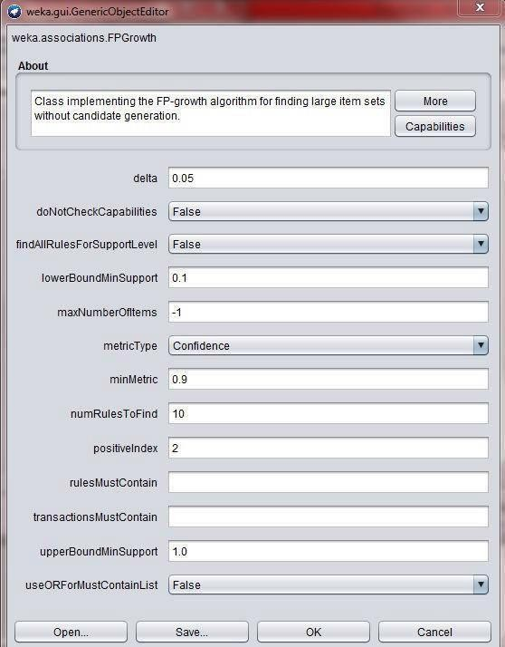

## Step 3:

Now run the FP Growth algorithm with the set values of minimum support and the confidence. After running the weka generates the association rules and the respective confidence with minimum support as shown in the figure.

The above csv file has generated 5 rules as shown in the figure:

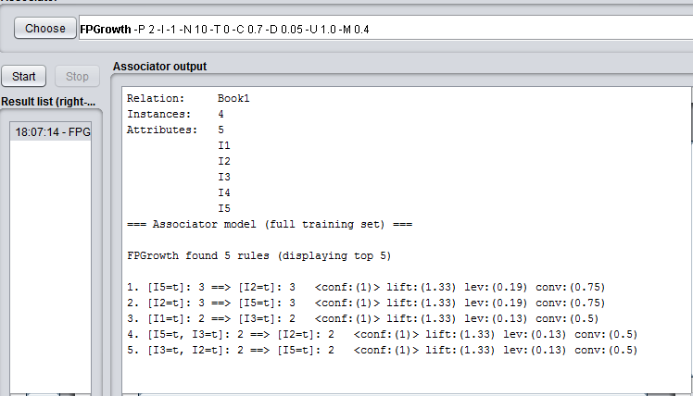

## Conclusion:

As we have seen the total rules generated by us manually and by the weka are matching, hence the rules generated are 5.

Exercise

1. Apply FP-Growth algorithm on Blood Transfusion Service Center data set

# Record Notes

**Experiment 7: Decision Tree Induction**

# Aim: Generate a Decision Tree by using J48 algorithm.

## DESCRIPTION:

Decision tree learning is one of the most widely used and practical methods for inductive inference over supervised data. It represents a procedure for classifying categorical database on their attributes. This representation of acquired knowledge in tree form is intuitive and easy to assimilate by humans.

## ILLUSTRATION:

Build a decision tree for the following data

|  |  |  |  |  |
| --- | --- | --- | --- | --- |
| AGE | INC  OM E | STUD ENT | CREDIT_RATIN G | BUYS_CO MPUTER |
| Youth | High | No | Fair | No |
| Youth | High | No | Excellent | No |
| Middle aged | High | No | Fair | Yes |
| Senior | Medium | No | Fair | Yes |
| Senior | Low | Yes | Fair | Yes |
| Senior | Low | Yes | Excellent | No |
| Middle aged | Medium | Yes | Excellent | Yes |
| Youth | Low | No | Fair | No |
| Youth | Medium | Yes | Fair | Yes |
| Senior | Medium | Yes | Fair | Yes |
| Youth | Medium | Yes | Excellent | Yes |
| Middle aged | Medium | No | Excellent | Yes |
| Middle aged | High | Yes | Fair | Yes |
| Senior | Medium | No | Excellent | No |

The entropy is a measure of the uncertainty associated with a random variable. As uncertainty increases, so does entropy, values range from [0-1] to present the entropy of information

Entropy (D) = 

Information gain is used as an attribute selection measure; pick the attribute having the highest information gain, the gain is calculated by:

Gain (D, A) = Entropy (D) -  Where, D: A given data partition A: Attribute

V: Suppose we were partition the tuples in D on some attribute A having v distinct values D is split into v partition or subsets, (D1, D2….. Dj) , where Dj contains those tuples in D that have outcome Aj of A.

Class P: buys_computer=”yes” Class N: buys_computer=”no”

Entropy (D) = -9/14log (9/14)-5/15log (5/14) =0.940

Compute the expected information requirement for each attribute start with the attribute age Gain (age, D)

= Entropy (D) - 

= Entropy ( D ) – 5/14Entropy(Syouth)-4/14Entropy(Smiddle-aged)-5/14Entropy(Ssenior)

= 0.940-0.694

=0.246

Similarly, for other attributes, Gain (Income, D) =0.029 Gain (Student, D ) = 0.151

Gain (credit_rating, D) = 0.048

|  |  |  |  |
| --- | --- | --- | --- |
| Income | Student | Credit_rating | Class |
| High | No | Fair | No |
| High | No | Excellent | No |
| Medium | No | Fair | No |
| Low | Yes | Fair | Yes |
| medium | Yes | excellent | yes |

Now, calculating information gain for subtable (age<=30)

I The attribute age has the highest information gain and therefore becomes the splitting

* attribute at the root node of the decision tree. Branches are grown for each outcome of age. These tuples are shown partitioned accordingly.

Income=”high” S11=0, S12=2 I=0

Income=”medium” S21=1 S22=1 I (S21, S23) = 1

Income=”low” S31=1 S32=0 I=0

Entropy for income

E( income ) = (2/5)(0) + (2/5)(1) + (1/5)(0) = 0.4

Gain( income ) = 0.971 - 0.4 = 0.571

Similarly, Gain(student)=0.971 Gain(credit)=0.0208

Gain( student) is highest ,

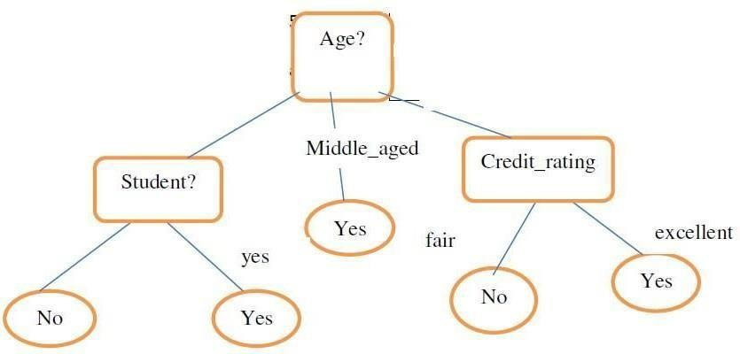

A decision tree for the concept buys_computer, indicating whether a customer at All Electronics is likely to purchase a computer. Each internal (non-leaf) node represents a test on an attribute. Each leaf node represents a class ( either buys_computer=”yes” or buys_computer=”no”.

first create a csv file for the above problem,the csv file for the above problem will look like the rows and columns in the above figure. This file is written in excel sheet.

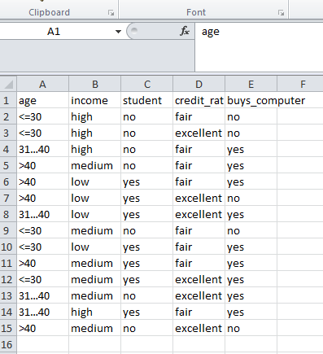

## Procedure for running the rules in weka:

Step 1:

Open weka explorer and open the file and then select all the item sets. The figure gives a better understanding of how to do that.

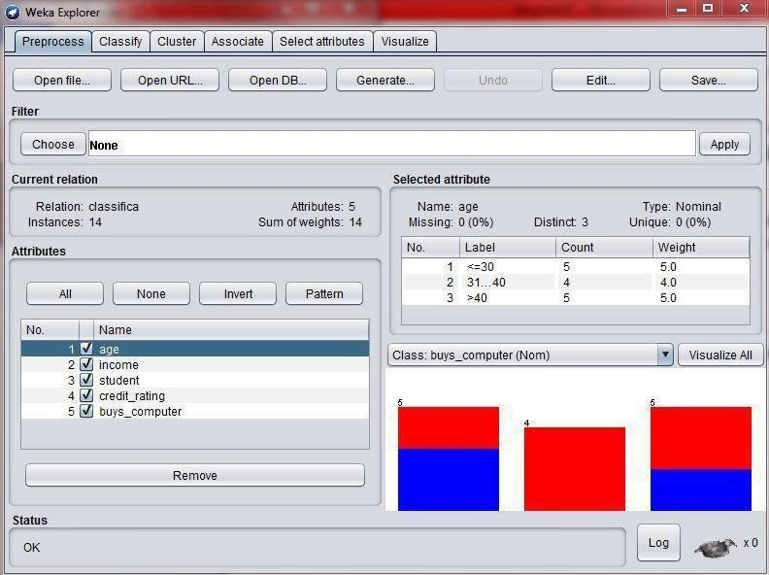

## Step2:

Now select the classify tab in the tool and click on start button and then we can see the result of the problem as below

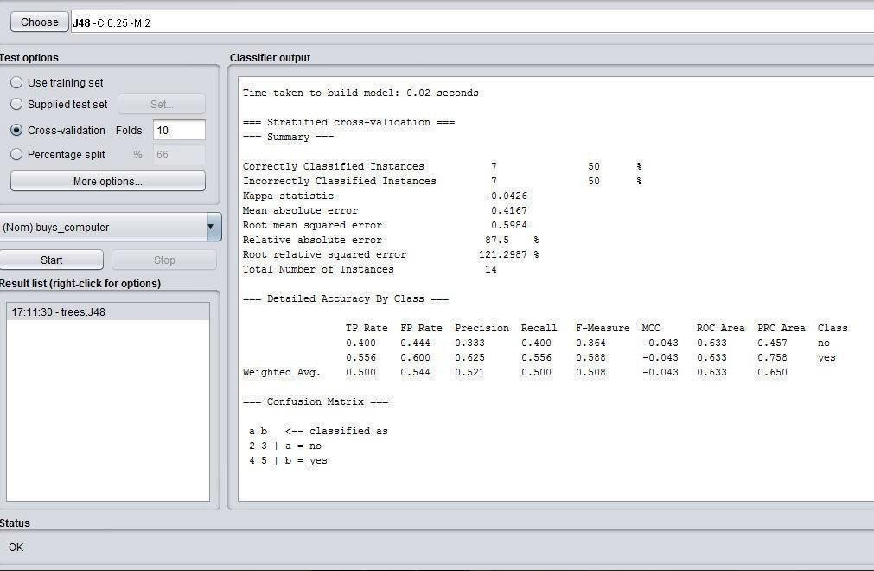

## Step3:

Check the main result which we got manually and the result in weka by right clicking on the result and visualizing the tree.

The visualized tree in weka is as shown below:

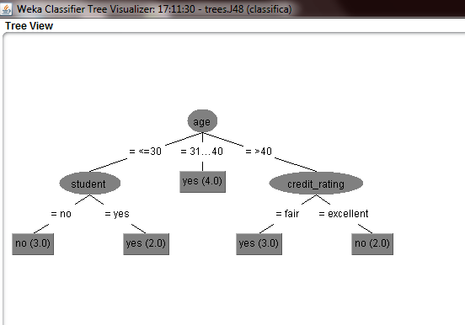

## Conclusion:

The solution what we got manually and the weka both are same.

Exercise:

1. Apply decision tree algorithm to book a table in a hotel/ book a train ticket/ movie ticket.

# Record Notes

**Experiment 8: Calculating information gain measures.**

Information gain (IG) measures how much “information” a feature gives us about the class. – Features that perfectly partition should give maximal information. – Unrelated features should give no information. It measures the reduction in entropy. CfsSubsetEval aims to identify a subset of attributes that are highly correlated with the target while not being strongly correlated with one another. It searches through the space of possible attribute subsets for the “best” one using the BestFirst search method by default, although other methods can be chosen. To use the wrapper method rather than a filter method, such as CfsSubsetEval, first select WrapperSubsetEval and then configure it by choosing a learning algorithm to apply and setting the number of cross- validation folds to use when evaluating it on each attribute subset.

Steps:

* + Open WEKA Tool.
  + Click on WEKA Explorer.
  + Click on Preprocessing tab button.
  + Click on open file button.
  + Select and Click on data option button.
  + Choose a data set and open file.
  + Click on select attribute tab and Choose attribute evaluator, search method algorithm

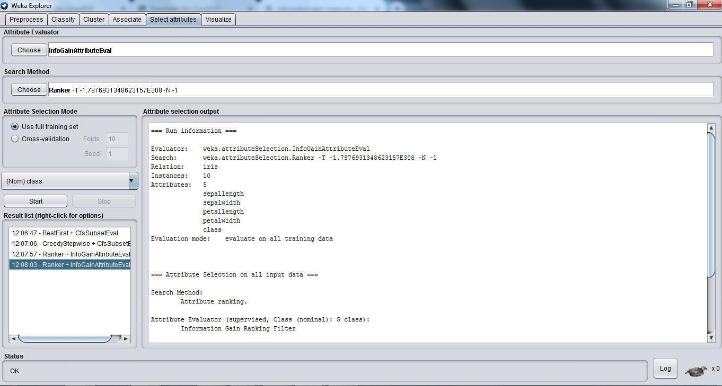

* + Click on start button.

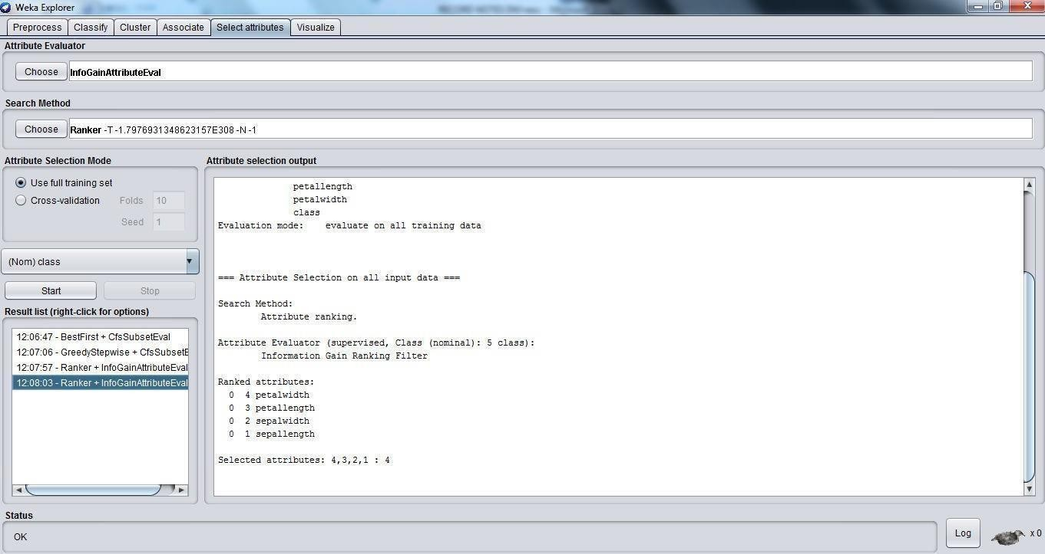

**Exercise**

Calculate the information gain on weather data set(for each attributes separately).

Record Notes

# Experiment 9: Classification of data using Bayesian approach

**AIM:** To apply naïve bayes classifier on a given data set.

## Description:

In machine learning, Naïve Bayes classifiers are a family of simple probabilistic classifiers based on applying Bayes‟ Theorem with strong (naïve) independence assumptions between the features

Example:

.

|  |  |  |  |  |
| --- | --- | --- | --- | --- |
| AGE | INCOME | STUDENT | CREDIT_RATING | BUYS_COMPUTER |
| <30 | High | No | Fair | No |
| <30 | High | No | Excellent | No |
| 31-40 | High | No | Fair | Yes |
| >40 | Mediu m | No | Fair | Yes |
| >40 | Low | Yes | Fair | Yes |
| >40 | Low | Yes | Excellent | No |
| 31-40 | Mediu m | Yes | Excellent | Yes |
| <=30 | Low | No | Fair | No |
| <=30 | Mediu m | Yes | Fair | Yes |
| >40 | Mediu m | Yes | Fair | Yes |
| <30 | Mediu m | Yes | Excellent | Yes |
| 31-40 | Mediu m | No | Excellent | Yes |
| 31-40 | High | Yes | Fair | Yes |
| >40 | Mediu m | No | Excellent | No |

## CLASS:

C1:buys_com puter = ‘yes’ C2:buys_com puter=’no’ **DATA TO BECLASSIFIED**

## :

X= (age<=30, income=Medium, Student=Yes, credit_rating=Fair)

P(C1): P(buys_computer=”yes”)= 9/14 =0.643

P (buys_computer=”no”) =5/14=0.357

Compute P(X/C1) and p(x/c2) weget:

1. P( age=”<=30” |buys_computer=”yes”)=2/9
2. P(age=”<=30”|buys_computer=”no”)=3/5
3. P(income=”medium”|buys_computer=”yes”)=4/9
4. P(income=”medium”|buys_computer=”no”)=2/5
5. P(student=”yes”|buys_computer=”yes”)=6/9
6. P(student=”yes” |buys_computer=”no”)=1/5=0.2
7. P(credit_rating=”fair ”|buys_computer=”yes”)=6/9
8. P(credit_rating=”fair” |buys_computer=”no”)=2/5

X=(age<=30, income=medium, student=yes, credit_rating=fair) P(X/C1): P (X/buys_computer=”yes”)=2/9*4/9*6/9*6/9= 32/1134

P(X/C2):P(X/buys_computer=”no”)=3/5*2/5*1

/5*2/5=12/125

P(C1/X)=P(X/C1)*P(C1)

P(X/buys_computer=”yes”)*P(buys_computer=”yes”)=(32/1134)*(9/14)=0.019

P(C2/X)=p(x/c2)*p(c2)

P (X/buys_computer=”no”)*P(buys_computer=”no”)=(12/125)*(5/14)=0.007

Therefore, conclusion is that the given data belongs to C1 since P(C1/X)>P(C2/X)

Checking the result in the WEKA tool:

In order to check the result in the tool we need to follow a procedure.

## Step 1:

Create a csv file with the above table considered in the example. the arfffile will look as shown below:

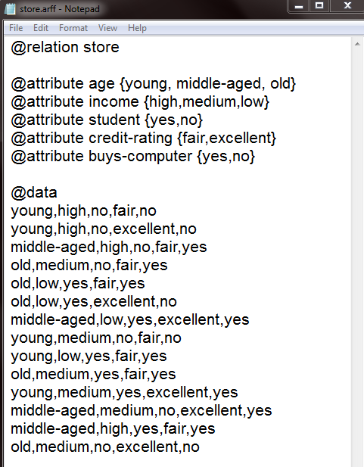

## Step 2:

Now open weka explorer and then select all the attributes in the table.



## Step 3:

Select the classifier tab in the tool and choose baye‟s folder and then naïve baye‟s classifier to see the result as shown below.

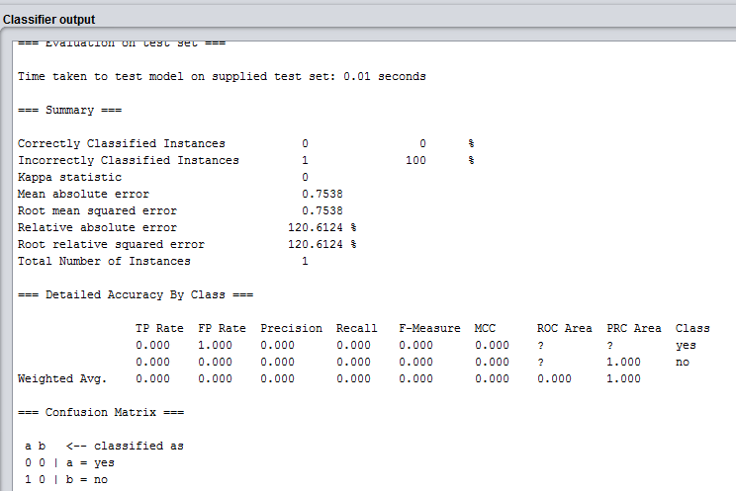

Exercise

1. Classify data (lung cancer/ diabetes /liver disorder) using Bayesian approach .

# Record Notes

**Experiment 10: Implementation of K-means algorithm**

## DESCRIPTION:

K-means algorithm aims to partition n observations into “k clusters” in which each observation belongs to the cluster with the nearest mean, serving as a prototype of the cluster. This results in partitioning of the data into Voronoi cells.

## ILLUSTRATION:

As a simple illustration of a k-means algorithm, consider the following data set consisting of the scores of two variables on each of the five variables.

|  |  |  |
| --- | --- | --- |
| I | X1 | X2 |
| A | 1 | 1 |
| B | 1 | 0 |
| C | 0 | 2 |
| D | 2 | 4 |
| E | 3 | 5 |

This data set is to be grouped into two clusters: As a first step in finding a sensible partition, let the A & C values of the two individuals furthest apart (using the Euclidean distance measure), define the initial cluster means, giving:

|  |  |  |
| --- | --- | --- |
| Cluster | Individual | Mean Vector(Centroid) |
| Cluster1 | A | (1,1) |
| Cluster2 | C | (0,2) |

The remaining individuals are now examined in sequence and allocated to the cluster to which they are closest, in terms of Euclidean distance to the cluster mean. The mean vector is recalculated each time a new member is added. This leads to the following series of steps:

|  |  |  |
| --- | --- | --- |
|  | A | C |
| A | 0 | 1.4 |
| B | 1 | 2.5 |
| C | 1.4 | 0 |
| D | 3.2 | 2.82 |
| E | 4.5 | 4.2 |

Initial partitions have changed, and the two clusters at this stage having the following characteristics.

|  |  |  |
| --- | --- | --- |
|  | Individual | Mean vector( Centroid) |
| Cluster 1 | A,B | (1,0.5) |
| Cluster 2 | C,D,E | (1.7,3.7) |

But we cannot yet be sure that each individual has been assigned to the right cluster. So, we compare each individual‟s distance to its own cluster mean and to that of the opposite cluster. And, we find:

|  |  |  |
| --- | --- | --- |
| I | A | C |
| A | 0.5 | 2.7 |
| B | 0.5 | 3.7 |
| C | 1.8 | 2.4 |
| D | 3.6 | 0.5 |
| E | 4.9 | 1.9 |

The individuals C is now relocated to Cluster 1 due to its less mean distance with the centroid points. Thus, its relocated to cluster 1 resulting in the new partition

|  |  |  |
| --- | --- | --- |
|  | Individual | Mean vector(Centroid) |
| Cluster 1 | A,B,C | (0.7,1) |
| Cluster 2 | D,E | (2.5,4.5) |

The iterative relocation would now continue from this new partition until no more relocation occurs. However, in this example each individual is now nearer its own cluster mean than that of the other cluster and the iteration stops, choosing the latest partitioning as the final cluster solution. Also, it is possible that the k-means algorithm won‟t find a final solution. In this case, it would be a better idea to consider stopping the algorithm after a pre-chosen maximum number of iterations.

Checking the solution in weka:

In order to check the result in the tool we need to follow a procedure.

## Step 1:

Create a csv file with the above table considered in the example. the csv file will look as shown below:

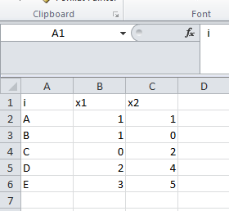

## Step 2:

Now open weka explorer and then select all the attributes in the table.

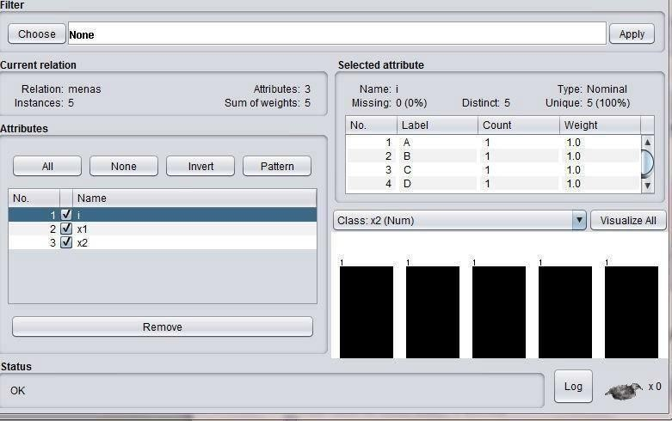

## Step 3:

Select the cluster tab in the tool and choose normal k-means technique to see the result as shown below.

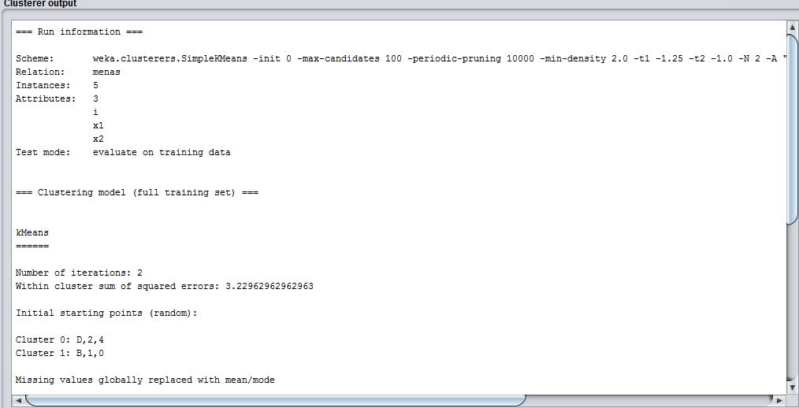

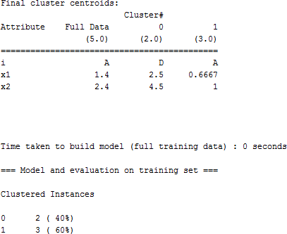

Exercise

1. Implement of K-means clustering using crime dataset.

# Record Notes

**Case Study**

* 1. Create Placement.arff file to identify the students who are eligible for

placements using KNN